Секція 1 – Композиційні матеріали на основі полімерів
УДК: 546.824-31

Synthesis of MXene/COF/Cu2O heterojunction for photocatalytic bactericidal activity and mechanism evaluation

Wei Wang,
Dr., As. Prof
School of Materials Science and Engineering,
Ocean University of China,
wangwei8038@ouc.edu.cn

Wenhui Ji,
Student of
Ocean University of China

Chao Feng
Ph.D.
Tobacco Research Institute of Chinese Academy of
Agricultural Sciences
fengchao020511@163.com

Abstract A Ti₃C₂/TpPa-1/Cu₂O composite material with high-efficiency bactericidal properties was prepared by in-situ growing TpPa-1-COF on Ti3C2-MXene and anchoring it with Cu₂O NPs. The heterostructure between TpPa-1 and Cu₂O regulated the energy band arrangement and an anti-blocking layer accelerated carrier flow, while Ti3C2 acted as a co-catalyst to promote carrier migration. The Ti3C₂/TpPa-1/Cu2O nanocomposites showed excellent antibacterial rates against S. aureus and P. aeruginosa, increasing by 50% and 33% compared with pure TpPa-1-COF.
Key words covalent connection. photocatalysis, antibacterial reactive oxygen species Ti₃C₂/TpPa-1/Cu₂O

Combining the advantages of heterojunctions made from various two-dimensional materials and metal oxide nanoparticles (NPs) is a practical approach to enhance photocatalytic sterilization efficiency. In this study, a Ti₃C₂/TpPa-1/Cu₂O composite material with potent bactericidal properties was prepared by in situ growing TpPa-1-COF, a stable semiconductor, on Ti₃C₂-MXene via Schiff base reaction and anchoring it with Cu₂O NPs. The two-dimensional heterostructure between TpPa-1 and Cu₂O in the Ti₃C₂/TpPa-1/Cu₂O nanocomposite effectively regulated the energy band arrangement. The anti-blocking layer at the interface accelerated carrier flow, while Ti₃C₂ acted as a co-catalyst, and the large built-in electric field generated at the interface promoted carrier migration between layers. The covalent bonding between MXene and COF greatly enhanced the material's stability. Electrochemical impedance spectroscopy and photoluminescence spectra showed that the material's photogenerated carrier migration rate and reactive oxygen species production were improved, and the carrier life was prolonged. The work function at the interface was analyzed using the first principle calculation based on density functional theory. Both TpPa-1/Ti₃C₂ interface and Ti₃C₂/Cu₂O interface had a large built-in electric field, promoting carrier migration between layers, resulting in efficient photocatalysis and reduced photocorrosion.
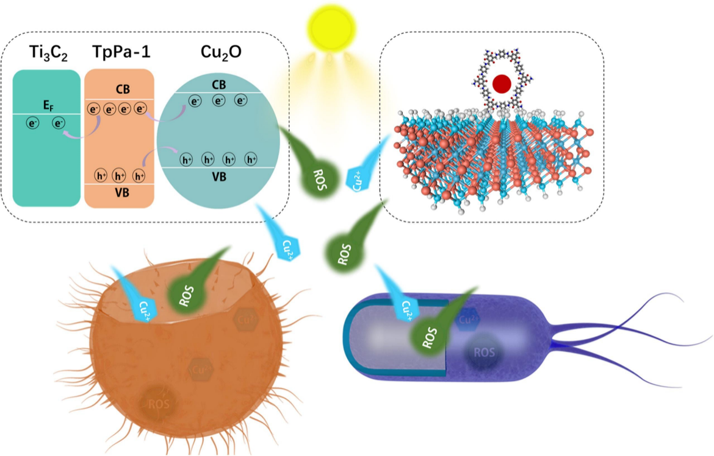
Fig. 1. Schematic of the sterilization mechanism of Ti₃C₂/TpPa-1/Cu₂O.
The Ti₃C₂/TpPa-1/Cu₂O nanocomposites obtained displayed excellent antibacterial rates against S. aureus and P. aeruginosa, with antibacterial rates of 98.90% and 99.62%, respectively, increasing by 50% and 33% compared to pure TpPa-1-COF. This work provides new insights into developing new photocatalytic antifouling agents for marine antifouling.

CONCLUSIONS
In the research the Schiff base reaction is utilized to create Ti₃C₂ and TpPa-1 covalently linked and anchored with Cu₂O NPs, resulting in the synthesis of Ti₃C₂/TpPa-1/Cu₂O with remarkable antibacterial properties. The two-dimensional heterostructure between TpPa-1 and Cu₂O in the Ti₃C₂/TpPa-1/Cu₂O nanocomposite effectively regulated the energy band arrangement. Moreover, the anti-blocking layer at the interface accelerated the carrier flow, and Ti₃C₂ acted as a co-catalyst and generated a large built-in electric field, which facilitated carrier migration between layers. Ti₃C₂/TpPa-1/Cu₂O demonstrated efficient photocatalysis and reduced photocorrosion, and the interface electric field promoted ROS production for effective sterilization. This work provides novel insights for the development of photocatalytic antifouling agents in marine environments.

References:
- Côté, A. P., Benin, A. I., Ockwig, N. W., O’Keeffe, M., Matzger, A. J., & Yaghi, O. M. (2005). Porous, Crystalline, Covalent Organic Frameworks. Science, 310(5751), 1166–1170. https://doi.org/10.1126/science.1120411
- 2. Feng, X., Ding, X., & Jiang, D. (2012). Covalent organic frameworks. Chemical Society Reviews, 41(18), 6010. https://doi.org/10.1039/c2cs35157a
- He, C., Li, C., Huang, W., Mei, S., Lin, H., Ou, Q., Zhang, Y., Guo, J., Zhang, F., & Xu, S. (2020). MXene/Polymer Membranes: Synthesis, Properties, and Emerging Applications. Chemistry of Materials, 32(5), 1703–1747. https://doi.org/10.1021/acs.chemmater.9b04408

